# Show Relationship between NDVI and Water Temperature for Kelp Farm Monitor Using IOT

Xi Sun V00025479

Ting Liu V00045129

Zheng Yin V00915261

## Purpose

The Internet of Things (IOT) refers to devices equipped with smart sensors that can transmit data to other connected devices through a closed network. Then, the data can be collected to systems that need this information for monitoring and analysis. The Internet of Things is playing an increasing role in many fields, including the kelp farming industry.

The Internet of Things in kelp farming is not a new concept: sensors and cameras have been installed in new farming equipment. The data from water temperature to water pressure are critical to helping kelp farmers and managers make business decisions of the farm environment, harvest time, kelp health or nutritional levels. However, deploying IoT technology in remote areas engaged in kelp farming is still a challenge, as information needs to be obtained from remote sensors to a local data center.

In our system model, what we need to achieve is how to combine the collected sensor information with the previous Arbutus-based NDVI processing system. This allows users to compare the collected hydrological information with the historical data of kelp distribution in satellite images to determine a more suitable farm location and harvest time. At the same time, we can also monitor hydrological conditions through different sensors to improve kelp health and reduce the risk of revenue reduction caused by low oxygen levels, water pollution and biological invasion.

Installing multiple sensors in the water, or making it floatable, can provide a wider coverage area, effectively monitoring the farm environment and applying near-real-time corrective actions for kelp health. The Internet of Things is an integral part of machine learning because data acquired over time can be used to create predictive models, leading to more confident decisions, timely alerts, and automated systems.

## Architecture

In our system, the ecological monitoring model based on the Internet of Things is mainly composed of three parts: data collection sensor node, data center, and processing center. In the multi-sensor network of the Internet of Things, the sensor nodes used may include various water temperature sensors, water pressure quality sensors, light intensity sensors, humidity sensors, and so on. In addition, GPS and wireless communication data transmission function modules are installed on all sensors. After the sensors collect various types of environmental monitoring data, they send the data to the localized data center. When the local data obtains the latest data, the processing center will be notified to process the corresponding data and satellite images and provide visualization tools for users.

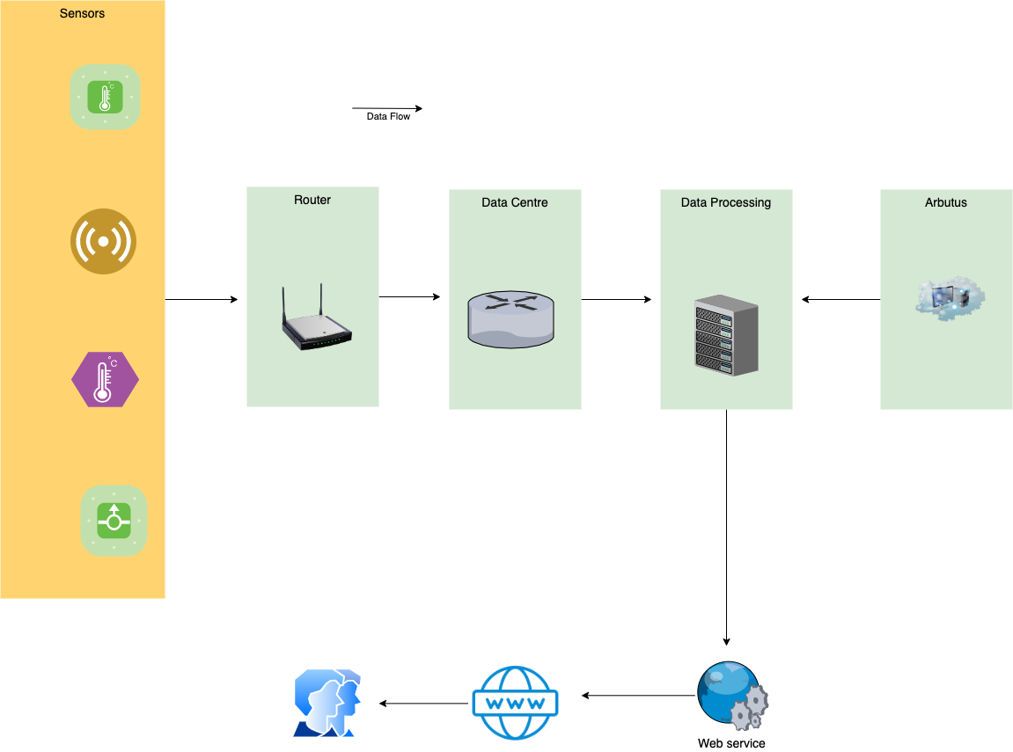

Figure 1: Architecture of IOT-KELP

In the Data Processing Server, it remotely accesses Satellite data from the Arbutus server where we have generated all NDVI imagery based on Sentinel2 data. We implemented a geo-database where we store all geographic parameters of NDVI and Sentinel2 satellite data, including coordinates of tiles (polygons), cloud coverage, vegetation coverage, etc. So we can filter out all relevant data using query language rather than manual operations.

The integrated image of kelp distribution based on NDVI imagery and remote sensor data will be exported to a map service as an add-on layer, so users can analyze the data in one interface.

## Data Source

To mock up the system, we collected the data from [Argo data sources](https://argo.ucsd.edu/data/). Argo is an open international program that collects information from inside the ocean using a fleet of robotic instruments that drift with the ocean currents and move up and down between the surface and a mid-water level. The data that Argo collects describes the temperature and salinity of the water and some of the floats measure other properties that describe the biology/chemistry of the ocean.

To investigate the relationship between ocean temperature and kelp distribution, the Argo data is one of the best references to our project. However, the problem is Argo instruments alway float far from the shore. So we decided to hack the data to mock up the sensor data in the kelp farm.

The original data format was csv which contains coordinates of instruments and the temperatures based on water pressure. The data was collected and saved by date.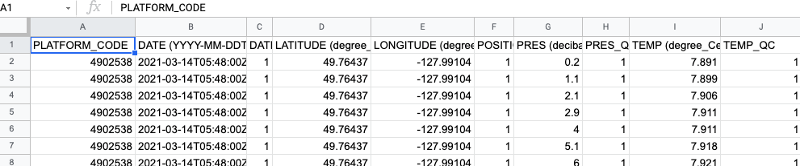

Figure 2: csv data structure from Argo

To simplify the data, we only chose the temperature of the water surface as a reference measure and mock up the data over one month. We were going to demonstrate the temperature change over time.

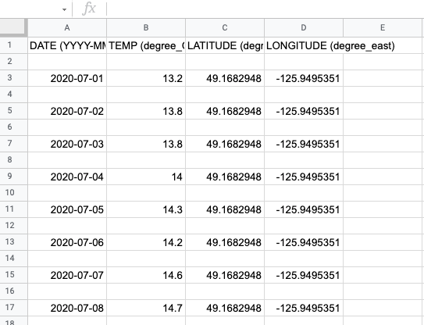

Figure 3: Mocked-up Data Showing Temperature over Time

## Data Processing

To connect to the previous Kelp project, we still chose Google Colab as our main data processing platform. Once the (simulated) data was obtained from Argo, we can extract the coordinates (longitude and latitude) of every sensor and pass them to colab where we show them on the map so users can see them intuitively.

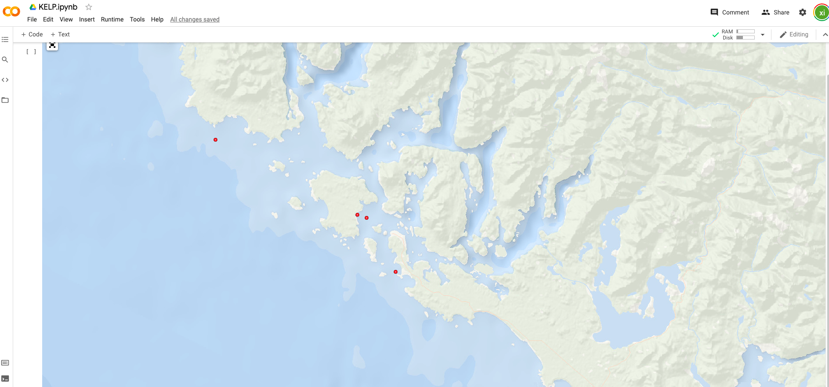

Figure 3: Sensors shown on the map

Users can use the mouse to select a single dot (sensor) on the map, or draw a box to select multiple sensors. Once the sensors were chosen, we passed the coordinates or the polygon boundary to Arbutus where we had built a gis database using Postgres and PostGis. According to the query coordinates, we can download the available sentinel 2 data from the database by http requests. Then, these spectral data will be processed in Colab to calculate NDVIs as what we did in phase 1.

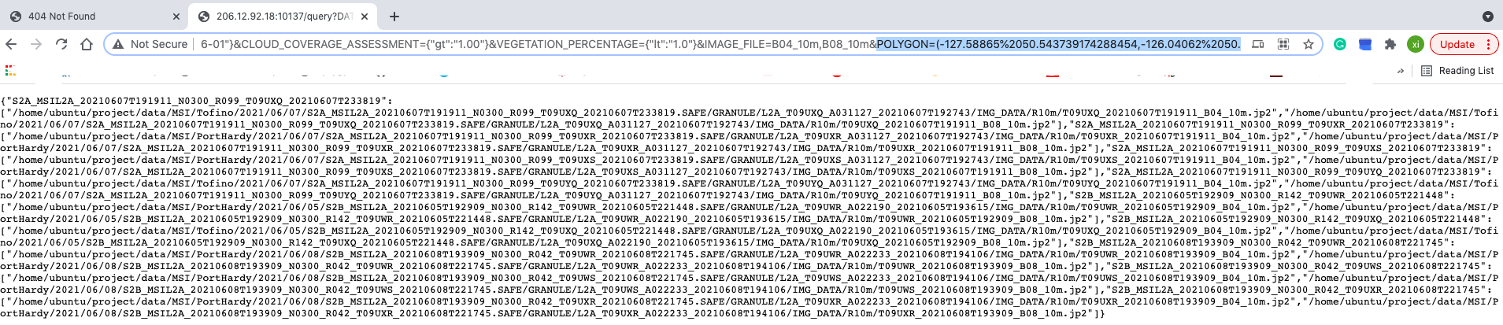

Figure 4: Get the Sentinel 2 Spectral Data From Arbutus

We also processed the sensor data read from Argo and visualized them by various charts, like histogram, dot chart. These charts are aligned with NDVI heatmap image and ESRI ocean basemap. So users can analyze the relations between temperature change and kelp distributions according to the sensor data and satellite data.

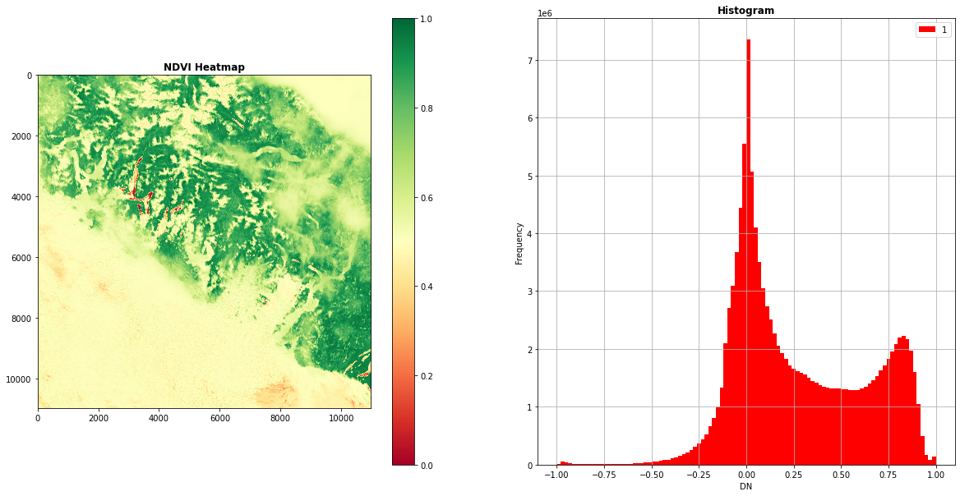

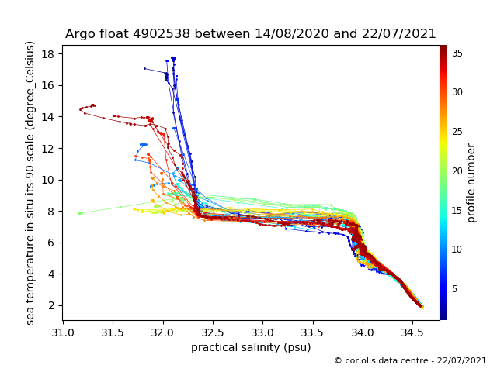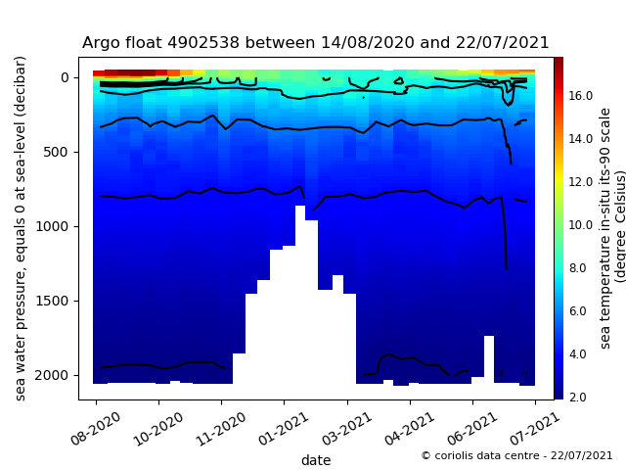

Unfortunately, the ipyleaflet package which we used to show the basemap has incomplete functions on colab, we did not have a chance to add the image layer on the map, otherwise, we can integrate the NDVI image with the basemap, which will make the comparison more convenient. Moreover, we can add the interactions on the map, for example, when we click or select the sensors, the corresponding statistics or diagrams will pop out. Anyway, we will transfer the processing platform to Arbutus virtual machine where we will implement a jupyter-notebook server to run all data processing and realize more map interactions for users.

## Discussion

From the perspective of the platform we have implemented, we can combine cloud data and local data well, and collect various hydrological data through IOT equipment for mutual verification and comparison with satellite images . This will be of great significance for the local kelp farmer to understand marine information and evaluate farming.

Our next consideration is the issue of scale. Although the core architecture has been established, there are still opportunities to improve the system to ensure that more diverse data can be involved. We will connect different data sources for data analysis and insight. Furthermore, all information can be sent to a wider range of companies in real time, not only Kelp farmers, but may also include government departments, fishermen, and tourism operators.

Of course, like any technology, the Internet of Things is not without its challenges. Safety and resilience are critical, and, in future development, security functions need to be built at the beginning of the process, rather than after the fact. Otherwise, the network and data may be hacked by cyber attacks. So this will also be the subject that we will study in the next step (deliverable).